-- What is the Highest salary for any job?

select max(salary_in_usd) as 'Highest Salary Paid (USD)'

from ds_salaries;

Screenshot 2024-06-24 101444.png

-- What is the Job with highest pay?

select job_title as 'Highest paid Job'

from ds_salaries

order by salary_in_usd desc

limit 1;

Screenshot 2024-06-24 101945.png

-- How many types of jobs are selected for the analysis?

select count(distinct job_title) as 'Total Job types'

from ds_salaries;

Screenshot 2024-06-24 102354.png

-- Which year has the vast amount paid in terms of salary?

select work_year as 'Highest paid Year'

from (select work_year, sum(salary_in_usd) as a

from ds_salaries

group by work_year) as b

order by a desc limit 1 ;

Screenshot 2024-06-24 104816.png

-- What is the total salary drawn on each year?

select work_year, sum(salary_in_usd) as 'Total salary drawn(USD)'

from ds_salaries

group by work_year;

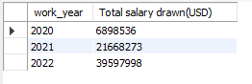

-- Is there any relationship between company size and salary?

select company_size, sum(salary_in_usd)as 'Total salary drawn by Each Size of Company'

from ds_salaries

group by company_size

order by 2 desc;

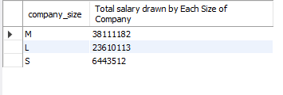

-- How does the experience of the employees plays role in deciding the salary

with tab1 as

(select *, row_number () over(partition by job_title order by experience_level)

from ds_salaries)

select experience_level, job_title, round(avg(salary_in_usd),2)as 'avg salary'

from tab1

group by experience_level, job_title;

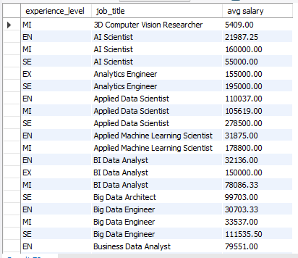

-- How does the employment type plays role in deciding the salary

with tab2 as

(select *, row_number () over(partition by job_title order by employment_type)

from ds_salaries)

select employment_type, job_title, round(avg(salary_in_usd),2)as 'avg salary'

from tab2

group by employment_type, job_title;

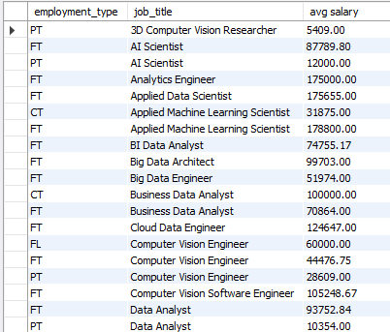

-- Is there any changes in the amount paid for the roles over the years

with tab3 as

(select *, row_number() over (partition by job_title order by work_year)

from ds_salaries)

select work_year, job_title, round(avg(salary_in_usd),2) as 'avg salary'

from tab3

group by work_year, job_title;

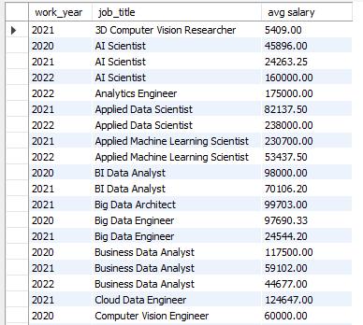

-- The amount of salary paid for the same job differ with company location

with tab4 as

(select *, row_number() over (partition by job_title order by company_location)

from ds_salaries)

select company_location, job_title, round(avg(salary_in_usd),2) as 'avg salary'

from tab4

group by company_location, job_title;

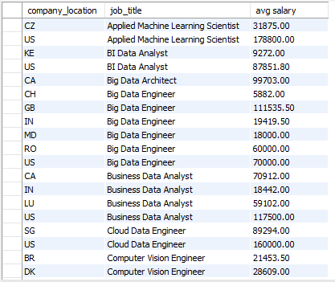

-- Does the remote job option affect salary

select job_title,remote_ratio, round(avg(salary_in_usd),2) as 'avg salary'

from ( select *, row_number() over (partition by job_title order by remote_ratio)

from ds_salaries) as a

group by job_title,remote_ratio;

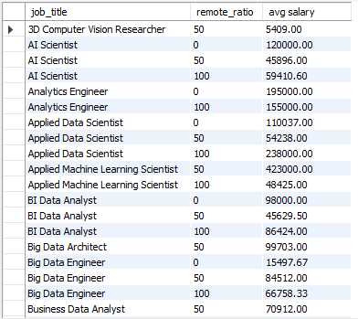

-- Find the Top 10 jobs with highest payment

select distinct job_title, salary_in_usd

from ds_salaries

order by salary_in_usd desc

limit 10;

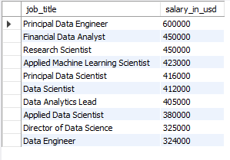

-- Find the Top 10 jobs with lowest payment

select distinct job_title, salary_in_usd

from ds_salaries

order by salary_in_usd

limit 10;

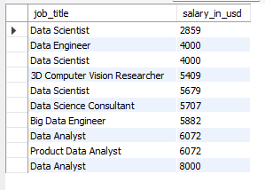

-- Find out the number of countries in which the highest paid job located

select count(distinct company_location)as 'Location'

from ds_salaries

where job_title = (select job_title

from ds_salaries

where salary_in_usd >=600000);

Screenshot 2024-06-25 201827.png

-- Find the Top 10 countries with highest payment

select company_location, salary_in_usd

from ds_salaries

order by salary_in_usd desc

limit 10;

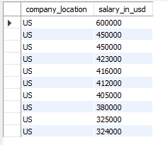

-- Find the Top 10 countries with lowest payment

select company_location, salary_in_usd

from ds_salaries

order by salary_in_usd

limit 10;

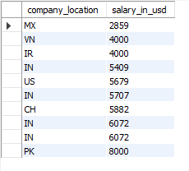

-- How many countries provide remote work option?

select count(distinct company_location) as 'Locations with remote option'

from ds_salaries

where remote_ratio > 0;

Screenshot 2024-06-25 202402.png

-- What is the average compensation drawn on each year?

select work_year, round(avg(salary_in_usd),2) as 'avg salary drawn(USD)'

from ds_salaries

group by work_year;

